HIST 111, Fall 2019
Dr. Leslie Madsen

How to read for this course

Many students arrive in their first college history course assuming it will be similar in format to the history classes they took in high school. More specifically, these students expect to read from a textbook, listen to the instructor, maybe look at some primary sources, and then take a test in which they demonstrate some level of mastery over that content.

History 111, on the other hand, guides you to think critically and creatively about the past rather than memorize political figures, political parties, dates, and facts.

The document explains why and how.

Learning theory

First we need to take a little trip through learning theory and how it applies in this course, as you need to know why I’m asking you to read particular kinds of course materials in different ways.

Below you’ll find Bloom’s Taxonomy of the cognitive domain. Some definitions:

- taxonomy: an orderly classification of objects or concepts
- cognitive: involving conscious intellectual activity such as knowing, perceiving, or decision-making.
- domain: a sphere or activity or knowledge

The graphic provides one way of looking at the lower- and higher-order thinking skills we expect students to develop and refine as undergraduates, no matter what they’re majoring in.

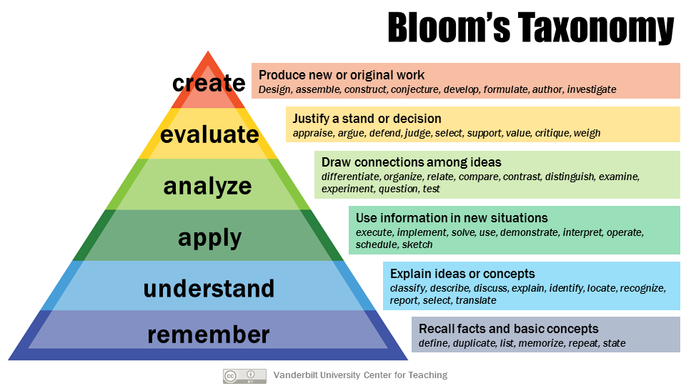
Image by Center for Teaching, Vanderbilt University, and used under a Creative Commons license.

When you first enter a field of study, you start at the bottom of the pyramid, acquiring basic facts and related concepts (Remembering). Gradually, you come to understand the why and how of those facts and concepts and can explain them to others (Understanding). Eventually, you gain enough facility with your understanding to apply those facts and concepts in new contexts (Apply). From there you move on up the pyramid to analysis, evaluation, and creation of original work. In this class, those levels might look like this:

Remember
You read in the textbook that Congress passed the Tariff of 1828, which placed a high tax on imported goods. Northern and Mid-Atlantic states supported the tariff, but the South opposed it.

You could, if asked, answer a multiple-choice question on an exam: “Which regions of the country supported the Tariff of 1828?”

Understand
Through further reading of the textbook, you learn the why and how of the tariff. The Tariff of 1828 sought to protect Northern states’ industries from inexpensive goods imported from Europe. The highly-taxed European goods became significantly more expensive than Northern-made goods, which meant Americans were more likely to buy American goods than European ones. This bolstered the Northern states’ economies. However, the Southern states did not have much manufacturing, and they imported a lot of manufactured goods from Europe. The high taxes (averaging 45%) meant that Southerners’ buying power decreased, so they bought fewer goods from Britain. Since Americans weren’t purchasing as many European goods, British manufacturers’ revenues also declined, which meant they could not afford to purchase as much cotton from the South. This hurt farmers and plantation owners, as well as the larger Southern economy. Accordingly, the South termed the tariff the “Tariff of Abominations.”

With this information, you could write a simple, straightforward paragraph in response to the exam question “How did the different regions of the U.S. respond to the Tariff of 1828? Why did the Tariff provide an economic advantage to the North but not the South?”

Apply
Your instructor asks you to look at graphs comparing the major imports and exports of the Northern and southern States in the first quarter of the 19th century. After studying the graphs for a few minutes, you could formulate a hypothesis as to why the Northern States advocated for a stronger protective tariff in 1828 (taxation averaging 45%) than in 1816 (taxation of 25-30%).

Analyze
You synthesize what you know about earlier economic developments to better understand different regions’ reactions to the Tariff of 1828. Because you had previously learned about the Tariff of 1816 and had read in the textbook about other aspects of the Southern states’ economies, you could participate in a lively small-group discussion with other students in which the instructor asks, “Southerners largely supported the Tariff of 1816, but they opposed the Tariff of 1828. We have already discussed the economic reasons for this shift in opinion. What cultural and political changes may have also influenced Southerners and Northerners to think so differently about tariffs in such a short period of time?”

Evaluate
Your instructor asks you to read the “South Carolina Exposition and Protest” (1828), in which John C. Calhoun criticized the Tariff of 1828 as unconstitutional and argued that states could reject, or nullify, federal laws. You then read the “South Carolina Ordinance of Nullification” (1832), in which state legislators in South Carolina declared the state would not recognize, pay, or impose the Tariff of 1828. Finally, you read President Andrew Jackson’s “Proclamation Regarding Nullification” (1832), in which Jackson argued that a single state cannot decide not to enforce a federal law because the U.S. was no longer a confederation of states but rather a union of them. He also highlighted that there were already established avenues through which South Carolina could have tested the tariff’s constitutionality without attempting to nullify the law.

Your instructor divides the class in half and asks each half to represent Jackson’s or Calhoun’s positions. The class participates in a structured debate about which argument was stronger—Calhoun’s/South Carolina’s or Jackson’s. While you personally believe Jackson was correct, you are assigned to argue for South Carolina. By drawing on what you know of the Southern states’ economic structures, political leanings, and cultural practices, you can see why Southerners favored Calhoun’s stance. You strengthen your side’s argument by describing the benefits of maintaining state sovereignty.

Create
For a class you’re taking on climate change, you read about how the Idaho legislature is fighting federal regulations designed to reduce carbon emissions. The state legislators are basing their argument on the doctrine of states’ rights. You write a research paper that explores how the current situation mirrors the Nullification Crisis of 1828-1832, what lessons might be drawn from that crisis, and argue that the legislators should adhere to federal law in this case.

Kinds of sources
When historians research the past and write about it, they classify their research materials into two broad categories: primary sources and secondary sources. It’s important that even students in a lower-division history course understand the difference between these categories.

We’ll go into greater detail early in the semester, but for now you need to understand that for historians, primary sources are those letters, diaries, laws, photos, artifacts, and other original items created at the historical moment under consideration. These original sources provide our clearest glimpses of the past because they were made by the people witnessing it.

Secondary sources, on the other hand, are commentaries on the past by people who did not witness or experience it first-hand. Historians create secondary sources (e.g., journal articles, books, documentaries, exhibitions) to argue for a particular interpretation of the past. Secondary sources almost always cite primary sources.

Sources we will read in this class—and how to read them

The American Yawp
The American Yawp is a textbook—a secondary source—written by several historians. Like most documents written by a large group of people (especially academics), it is not exactly a page-turner. It is largely chronological—it begins by describing the culture of some of the original, indigenous inhabitants of North America, then recounts the activities of those who visited or settled the land since the 15th century.

I do not expect you to memorize the names, dates, places, and events in The American Yawp. In fact, I don’t expect you to spend a lot of time reading and studying this text. Rather, when I assign reading in the textbook, I expect you to skim for understanding. You should come to class with a general knowledge of what the major issues were during the period of time covered by that chapter of The American Yawp. You should have a sense of which individuals and groups were engaging with these issues and why. (Note that the course schedule indicates on which sections of each American Yawp chapter you should spend your time, e.g. “AY chapter 2 (I, II, IV, VI).”)

So, for example, in the first chapter of The American Yawp, I don’t expect you to remember that “Inca recorders noted information in the form of knotted strings, or khipu.” Rather, I expect you to understand that Native American cultures and societies had sophisticated and nuanced ways of communicating about topics as varied as time, medicine, religion, kinship, and food preparation. I expect you to come to class knowing that indigenous peoples migrated due to changes in climate, animal migration, and other pressures, and that as they adapted to new regions and neighbors, indigenous people borrowed from one another’s cultures.

Primary sources from The American Yawp Reader and elsewhere
Although many of these primary sources will be brief and may appear straightforward, you should be investing a good deal of time in reading them closely and asking questions about them. If you get stuck, you might download worksheets from the National Archives designed to help you analyze documents, photos, and political cartoons.

The kinds of questions you should be trying to answer about these primary sources include:
- What is the purpose of this source?
- When was it created?
- Who created it?
- Who was the intended audience?
- What does it reveal about the culture or politics—the habits, beliefs, and values—of the U.S. at the time of its creation?
- What additional questions do you have about this source?

It’s a good idea to print out primary sources, mark them up with a pen, and bring them to class. (You can, of course, also annotate them electronically if that’s what you prefer.)

Saints and Citizens and Mongrel Nation
These two books are from a genre known as monographs. A monograph is a nonfiction book, typically scholarly in tone, on a single subject. It usually is written by a single expert on the subject (who often becomes an expert by researching and writing the book).

You need to read monographs very carefully. I encourage you to highlight and annotate your book or ebook. If you don’t want to write in your book, you can flag key passages with sticky notes on which you write your questions or observations. If you’re reading an ebook that lets you copy and paste passages, you can create a separate document for these quotes and your questions or commentary about them.

You don’t want to try to read a monograph when you’re tired. You need to have enough intellectual energy to identify and analyze the argument the author is making. Furthermore, you should be looking at the footnotes or endnotes to see what on kind of sources they’re basing their arguments.

Also, by approaching a monograph when you’re fresh, you’re far more likely to be able to follow the scholar’s narrative and reasoning. You may even find yourself enjoying the book so much that you start searching the internet for more information on the subject.

