History 111, Fall 2019
Dr. Leslie Madsen

Final exam questions

Instructions

Please read these instructions carefully.

Below are three potential final exam questions. Two of them will appear on the exam itself. You will write a response to one of them.

Here’s how our final exam will work:

1. Dr. Madsen will distribute the two-question exam at the end of class on Thursday, December 12.
- To receive those two questions, you must be in class that day and participate in the final exam review with other students.
- If you miss that class, you must arrange to pick up the exam from Dr. Madsen or Noah.

2. You will write a response to one of those questions. To submit your exam, upload your response to your student folder in Google Drive by 11:30 a.m. on Thursday, December 19.
- You can take the exam outside of class, as long as you upload it by the deadline.
- If you wish, you may take the exam in class on December 19th, assuming you bring a device that will allow you to upload your essay by the deadline.

Rules

- The exam is open note and open book, but must be completed by you, not in collaboration with other students (beyond your participation in the review session on December 12).
- Aim for 500-650 words. The essay must not exceed 750 words. Make your argument and support it with sources.
- Cite your sources using footnotes.
  - For the purposes of the final exam, it’s fine to simply cite “The American Yawp, Chapter 2, Section 3,” since there aren’t any page numbers in the digital version.
  - Similarly, feel free to cite Mongrel Nation with just the author’s name and page number(s).
  - Cite any other sources with the author’s name and title. For example, if you’re citing Chapter 3, Source 1, you’d write “Olaudah Equiano, The Interesting Narrative of the Life of Olaudah Equiano.” (If you’re not sure of the author or title of a primary source, if you scroll down to the bottom of each source in The American Yawp Reader, you’ll find the full citation.)

The questions

1. The roles available to women changed considerably in the century from the beginning of the American Revolution to the end of Reconstruction. Progress towards women’s rights was not linear, however, and women gained greater autonomy in fits and starts. What tactics or strategies did women (of various racial/ethnic backgrounds and socioeconomic classes) use to assert their autonomy? Which of these efforts do you see as most successful, and why? Be sure to provide specific examples to support your argument.

2. In Mongrel Nation, Clarence Walker writes that “American exceptionalism has always had a racial subtext” (6). For the purposes of this essay, assume Walker is correct. Using at least three different sources we read or viewed in History 111 in November or December, provide at least three historical examples that align with Walker’s statement. Explain how each example serves as evidence of the truth of Walker’s statement. Remember to define “American exceptionalism.”

3. Taken collectively, the images below reveal much about the beliefs and values of Americans in the nineteenth century. Study them carefully, then identify one belief or value represented in at least four of the images. (Remember to look for visual similarities across images.) As we did in class when we analyzed American Progress, you need to focus on what the paintings or photos express as the moment they were created as much as the historical events they document. Refer to details in at least four of these images, as well as primary and secondary sources used in the course, to argue for the existence of that belief or value.

You will find, and definitely should examine closely, the larger digital versions at https://hist111.doinghistory.com/final-images/.

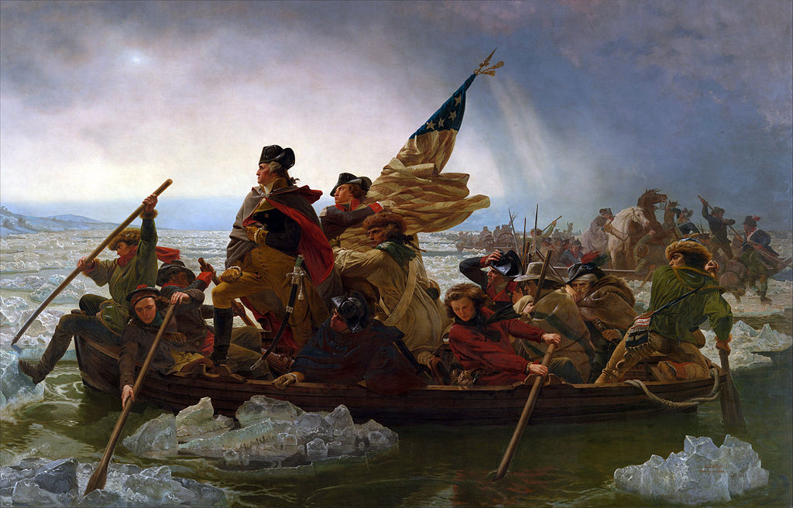  Emanuel Leutze, Washington Crossing the Delaware (1851). Metropolitan Museum of Art, via Wikipedia. | 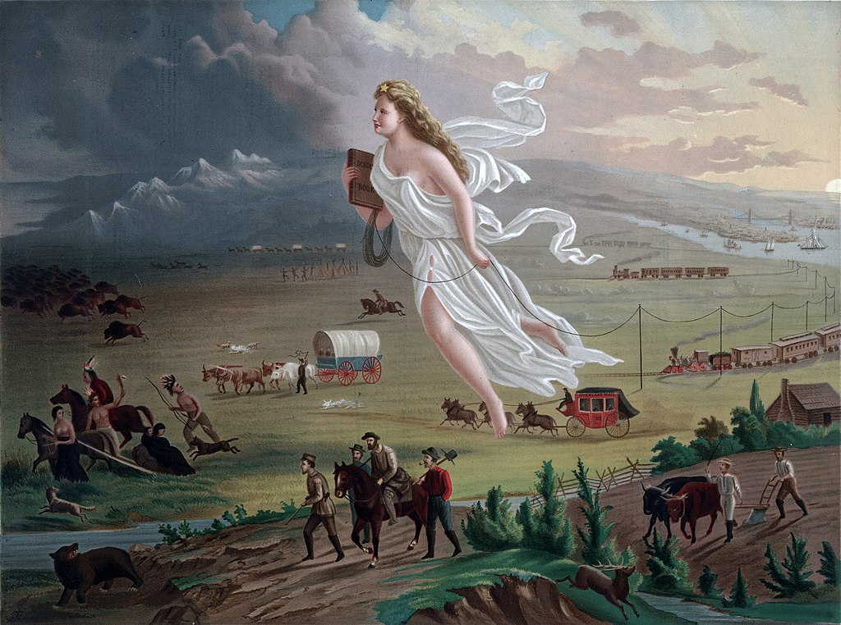  John Gast, American Progress (1872). Autry National Center, via Wikimedia Commons. | 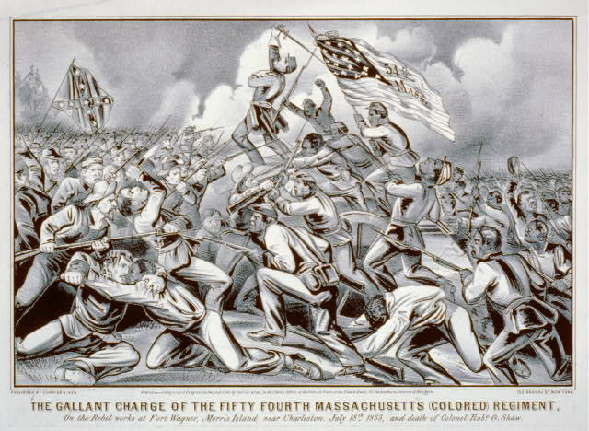  Currier & Ives, The gallant charge of the fifty fourth Massachusetts (colored) regiment: on the rebel works at Fort Wagner, Morris Island, near Charleston, July 18th 1863, and death of Colonel Robt. G. Shaw, 1863. Via Library of Congress.
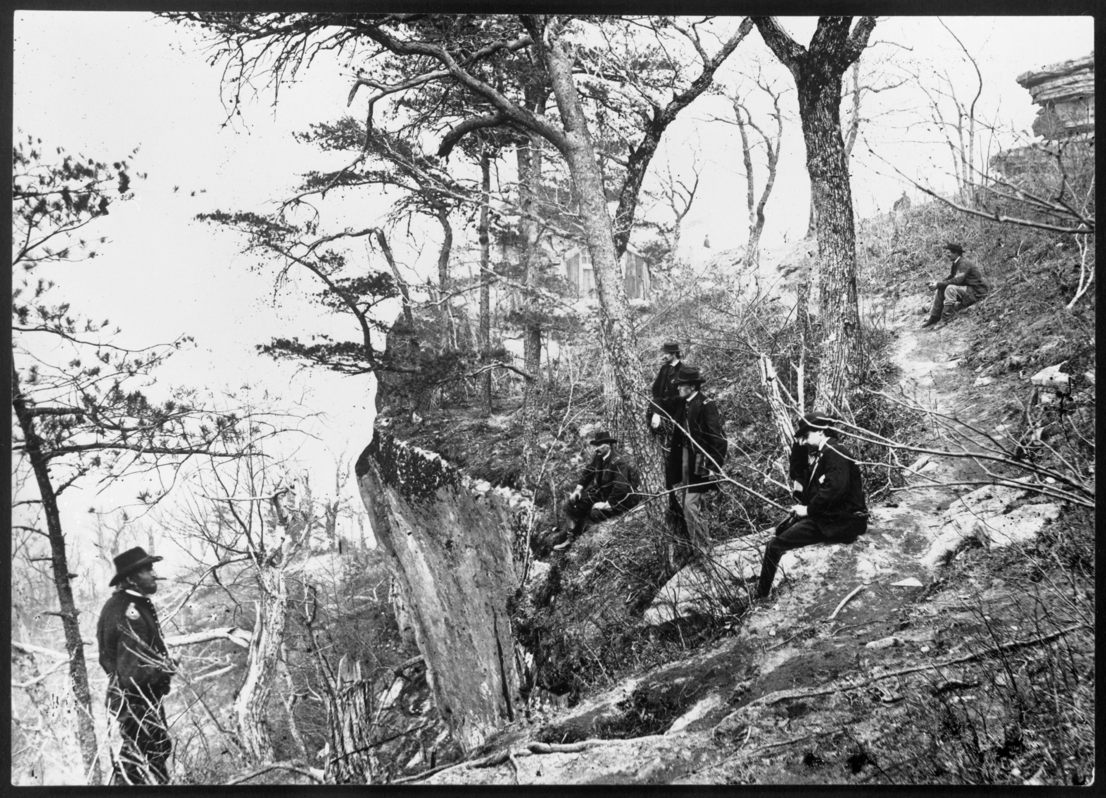  General Grant on Lookout Mountain, 1863. Via Tennessee Virtual Archive. | 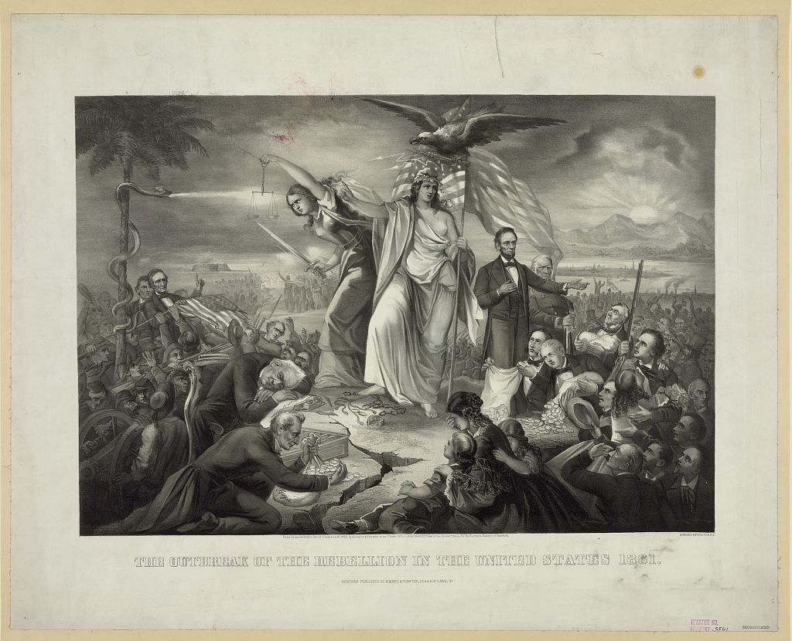  Christopher Kimmel, The Outbreak of the Rebellion in the United States, 1861. Via Library of Congress. | 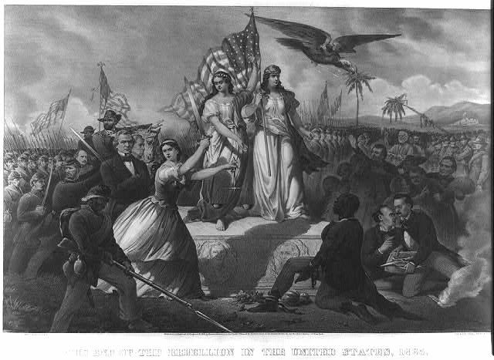  Christopher Kimmel, The End of the Rebellion in the United States, 1865. Via Library of Congress.
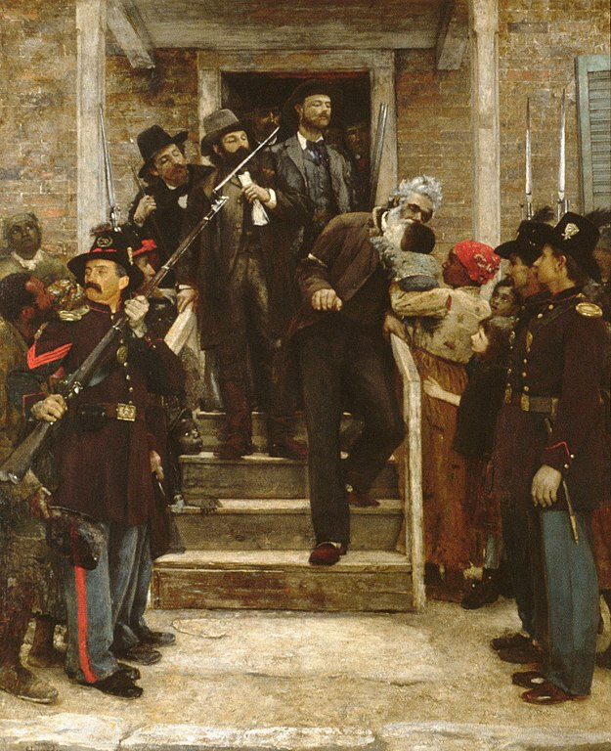  Thomas Hovenden, The Last Moments of John Brown (circa 1882-1884). Metropolitan Museum of Art, via Wikimedia Foundation | 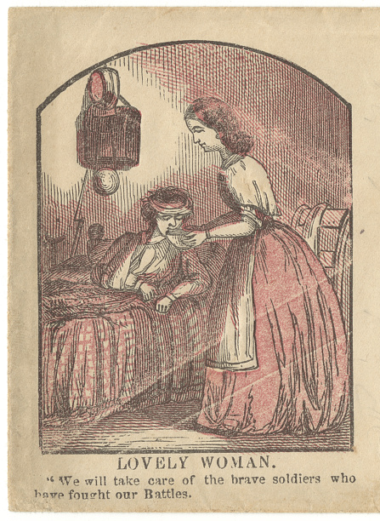  Image from Civil War envelope. 1861-1865. Via Library of Congress. | 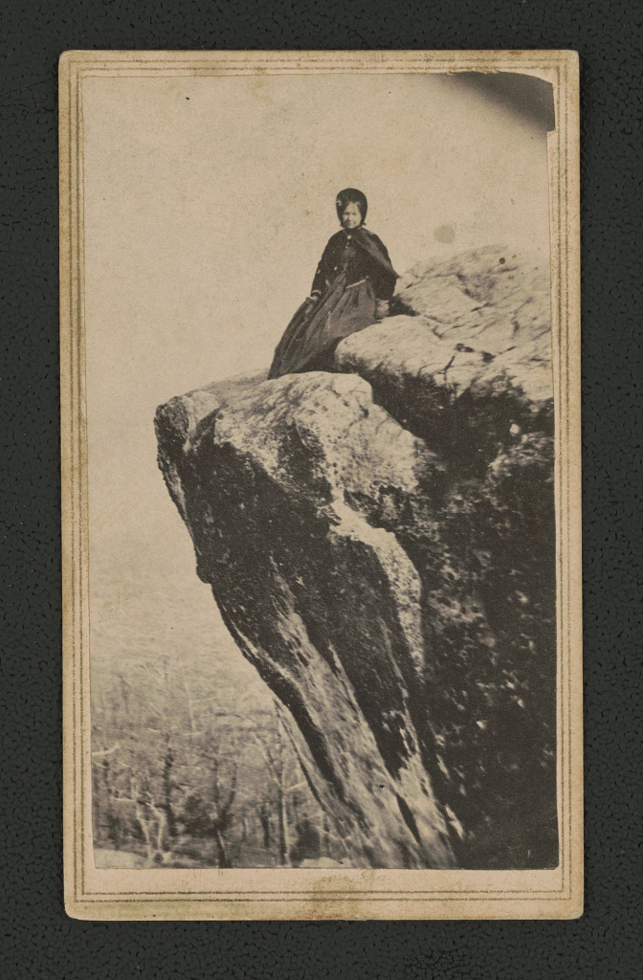  Thomas J. Merritt, Grace Babcock, Civil War nurse, sitting atop Lookout Mountain. 1860s. Via Library of Congress.
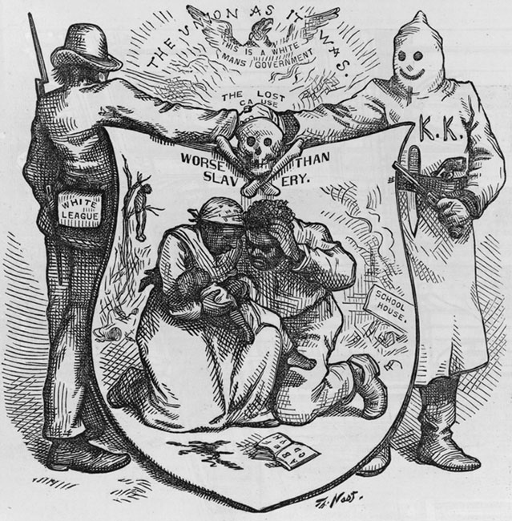
Thomas Nast, "The Union as it was / The lost cause, worse than slavery." Harper's Weekly, v. 18, no. 930 (24 Oct 1874), p. 878. Via Library of Congress.

How your response will be evaluated

Your response will be evaluated on how well you state your argument, support it, and cite your sources. Your essay should be largely free of errors in grammar, usage, and spelling. Essays of inappropriate length and those posted after the deadline will receive a lower grade.

